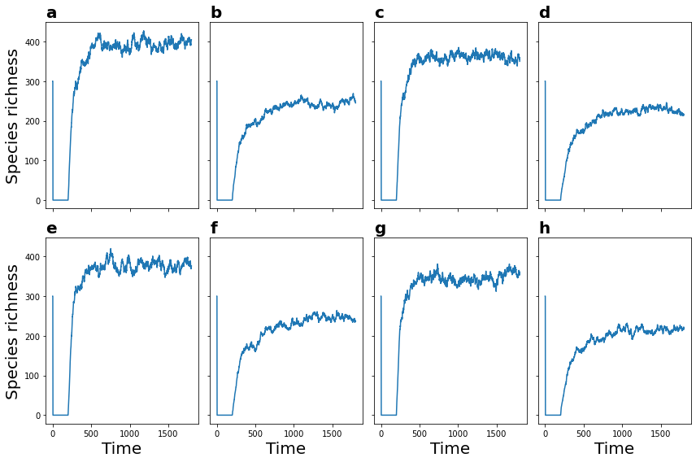

Figure S1 Species richness dynamics for different combinations of three parameters: variance for growth rate ($σ_{r}$), the variance of interaction strength ($σ_{α}$), and the mean introduction rate ($λ$). The dynamics of species richness passes through three phases. The three phases observed are the exponential decay in a closed system for 200-time steps and, a linear increase when new species are introduced, plateauing to the stationary state. Community snapshots for the last 1000 steps (the stationary phase) are used for further analyses.

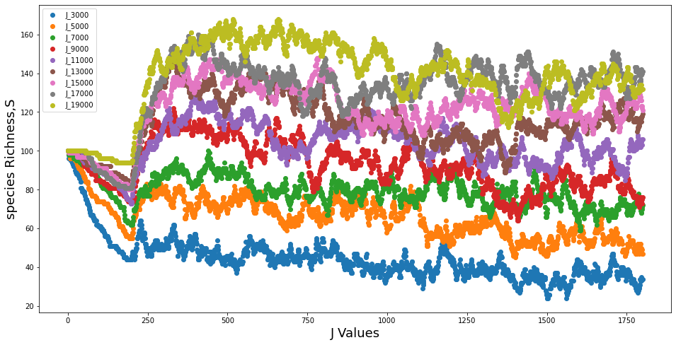
Figure S2 Community effects on species richness. The dynamic of species richness for various community size values.

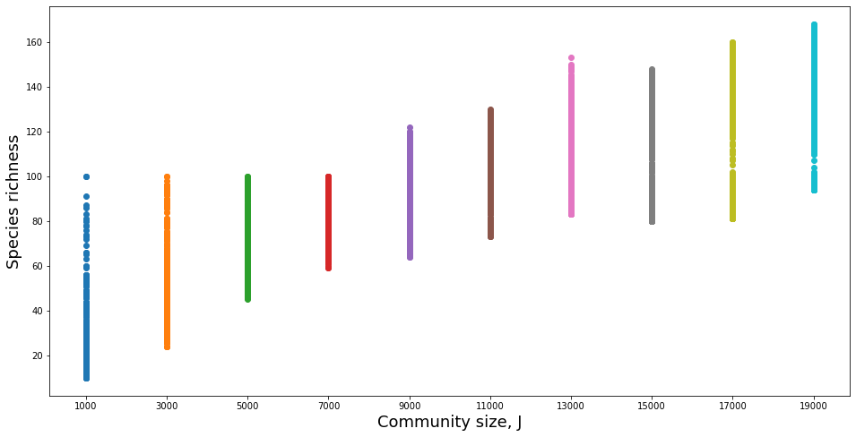
Figure S3 Community effects on species richness. The dynamic of species richness for various community size values. The $R^{2}$ value for the relationship between the change in J values and species richness is 0.96.

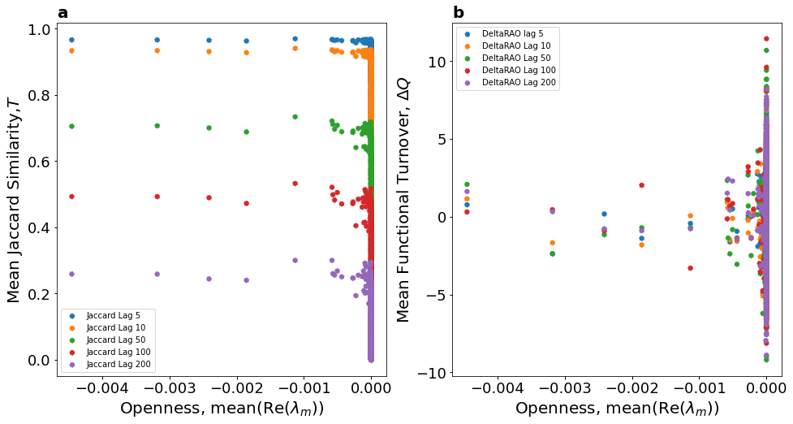

Figure S4 Jaccard Similarity and functional turnover at different time lags as a function of the average lead eigenvalue.

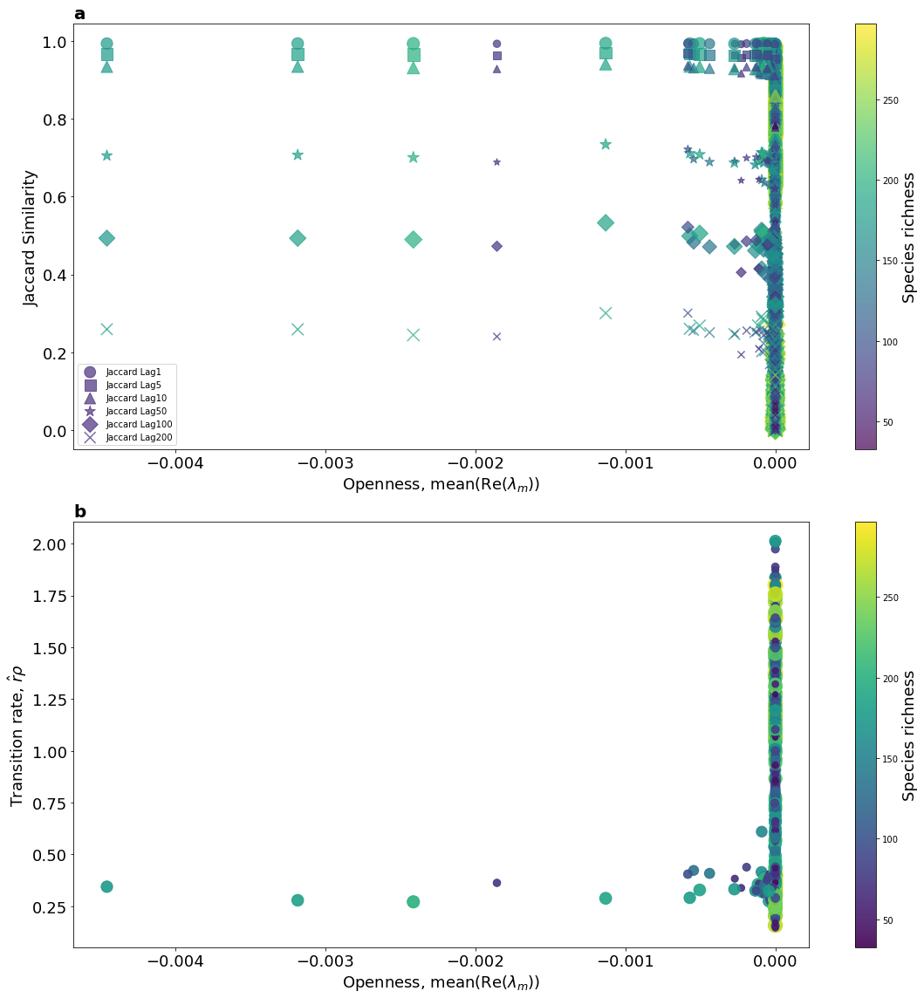
Figure S5 Lead eigenvalue as an indicator of community openness. Pannel (a) The time-average Jaccard compositional similarity under different time lags against the time-average of the real parts of the lead eigenvalues for the 1000 simulated communities during the stationary phase. The point size and colour reflect the species richness in the community. Panel (b) The transition rate (as the product of average introduction rate and average intrinsic growth rate) against the time-average of the real parts of the lead eigenvalues for the 1000 simulated communities during the stationary phase.

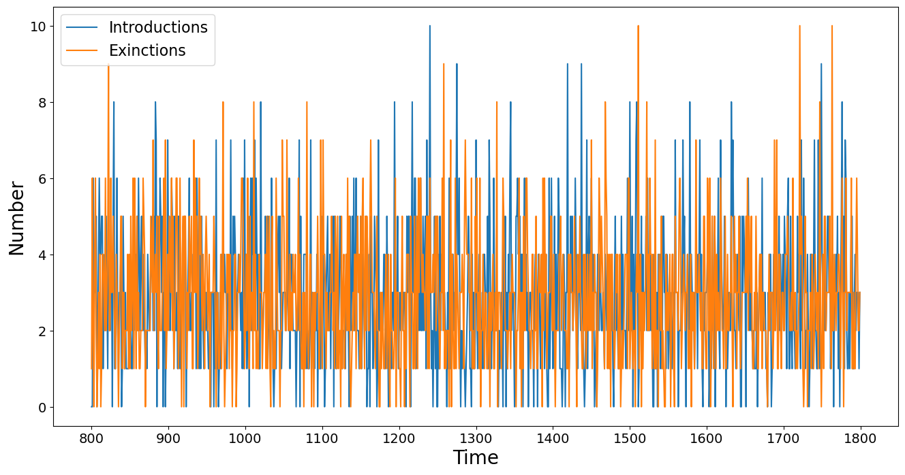
Figure S6 Introduction rate and extinction rate. The plot shows the number of species introduced and gone extinct in the last 1000 steps of the simulation.
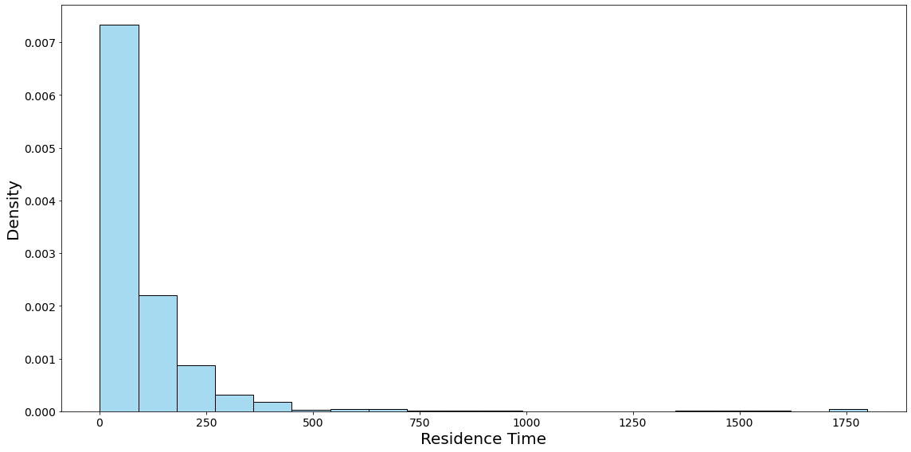
Figure S7 Distribution of species residence time.

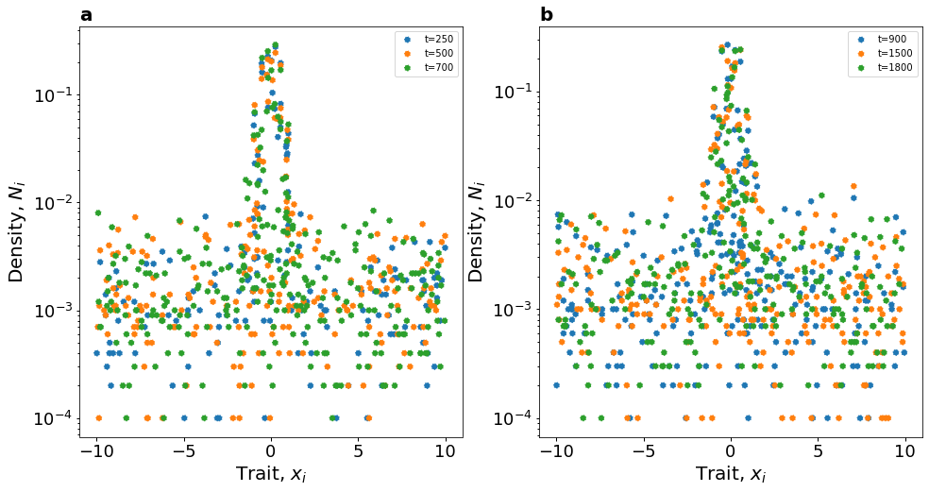
Figure S8 Trait distribution at different snapshots in the transient and stationary phase.
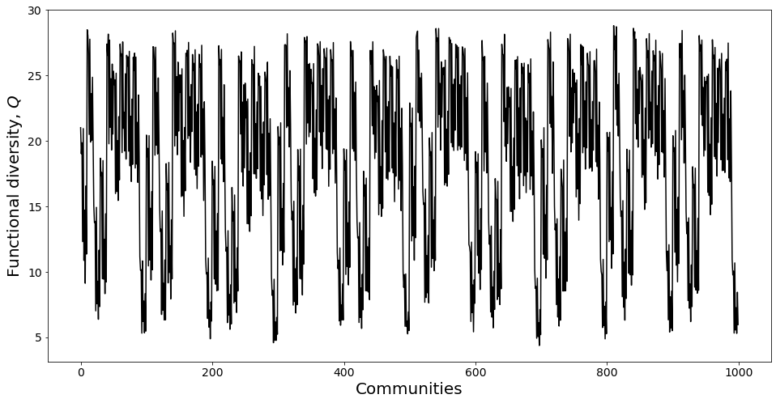
Figure S9 Mean functional diversity for the 1000 modelled communities in the stationary phase.

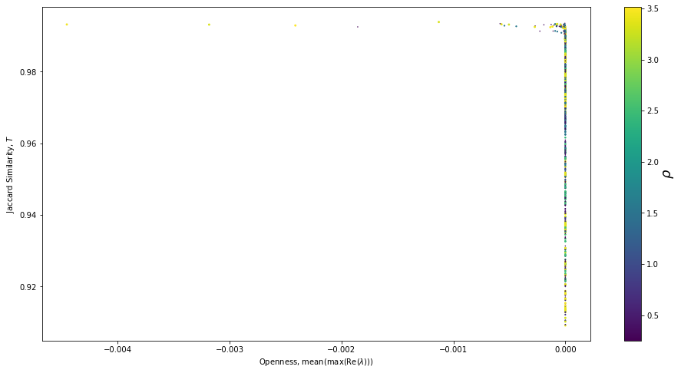
Figure S10 Lead eigenvalue as an indicator of community openness. The time-average Jaccard lag 1 compositional similarity against the time-average of the real parts of the lead eigenvalues for the 1000 simulated communities during the stationary phase. The point size and colour reflect the mean introduction rate.
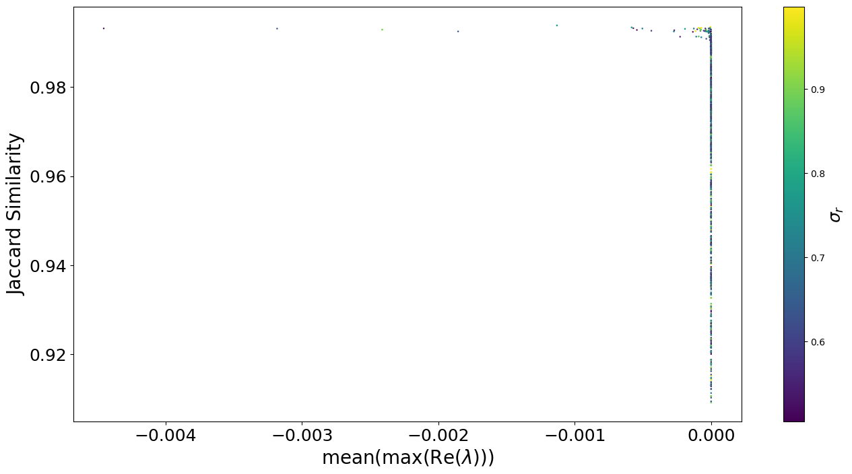
Figure S11 Lead eigenvalue as an indicator of community openness. The time-average Jaccard lag 1 compositional similarity against the time-average of the real parts of the lead eigenvalues for the 1000 simulated communities during the stationary phase. The point size and colour reflect the width of intrinsic growth rate Gaussian kennel.

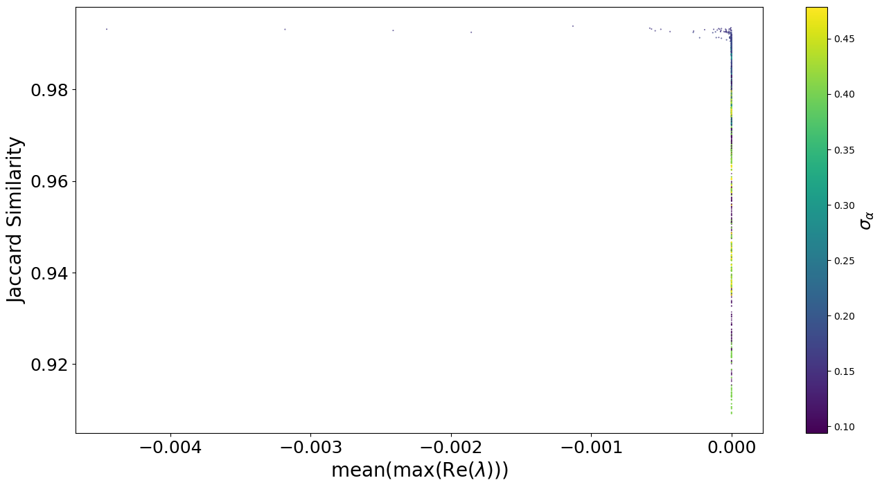
Figure S12 Lead eigenvalue as an indicator of community openness. The time-average Jaccard lag 1 compositional similarity against the time-average of the real parts of the lead eigenvalues for the 1000 simulated communities during the stationary phase. The point size and colour reflect the width of interaction strength Gaussian kennel.

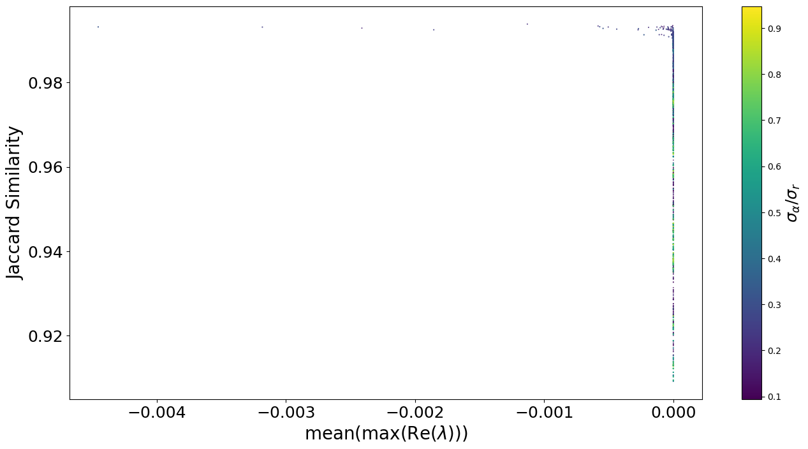
Figure S13 Lead eigenvalue as an indicator of community openness. The time-average Jaccard lag 1 compositional similarity against the time-average of the real parts of the lead eigenvalues for the 1000 simulated communities during the stationary phase. The point size and colour reflect the ratio of the width of interaction strength to the width of intrinsic growth rate.

